Hello World Bash Shell Script
Now, it is time to write our first, most basic bash shell script. The whole purpose of this script is nothing else but print "Hello World" using echo command to the terminal output. Using any text editor create a new file named hello-world.sh containing the below code:
#!/bin/bash

echo "Hello World"
Once ready, make your script executable with thechmod command and execute it using relative path ./hello-world.sh:
$ chmod +x hello-world.sh
$ linuxconfig.org:~$ ./hello-world.sh
Hello World
$

Variables
Variables are the essence of programming. Variables allow a programmer to store data, alter and reuse them throughout the script. Create a new script welcome.sh with the following content:
#!/bin/bash

greeting="Welcome"
user=$(whoami)
day=$(date +%A)

echo "$greeting back $user! Today is $day, which is the best day of the entire week!"
echo "Your Bash shell version is: $BASH_VERSION. Enjoy!"

Numeric and String Comparisons
In this section, we are going to learn some basics of numeric and string bash shell comparisons. Using comparisons, we can compare strings ( words, sentences ) or integer numbers whether raw or as variables. The following table lists rudimentary comparison operators for both numbers and strings:

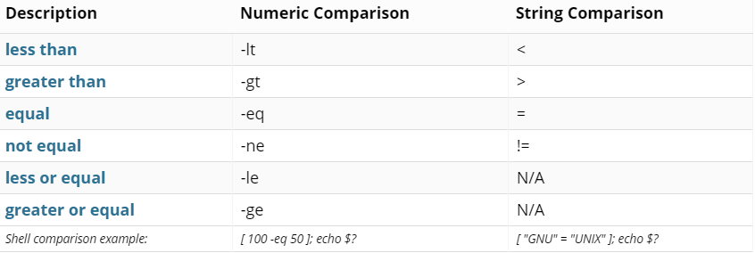

if Statement
Bash if conditionals can have different forms. The most basic if statement takes the following form:
if TEST-COMMAND
then
STATEMENTS
fi
Copy
The if statement starts with the if keyword followed by the conditional expression and the then keyword. The statement ends with the fi keyword.
If the TEST-COMMAND evaluates to True, the STATEMENTS gets executed. If TEST-COMMAND returns False, nothing happens, the STATEMENTS gets ignored.
In general, it is a good practice to always indent your code and separate code blocks with blank lines. Most people choose to use either 4-space or 2-space indentation. Indentations and blank lines make your code more readable and organized.
Let’s look at the following example script that checks whether a given number is greater than 10:
#!/bin/bash

echo -n "Enter a number: "
read VAR

if [[ $VAR -gt 10 ]]
then
echo "The variable is greater than 10."
fi

Save the code in a file and run it from the command line:
bash test.shCopy
The script will prompt you to enter a number. If, for example, you enter 15, the test command will evaluate to true because 15 is greater than 10, and the echo command inside the then clause will be executed.
The variable is greater than 10.
Copy

if..else Statement
The Bash if..else statement takes the following form:
if TEST-COMMAND
then
STATEMENTS1
else
STATEMENTS2
fi
Copy
If the TEST-COMMAND evaluates to True, the STATEMENTS1 will be executed. Otherwise, if TEST-COMMAND returns False, the STATEMENTS2 will be executed. You can have only one else clause in the statement.
Let’s add an else clause to the previous example script:
#!/bin/bash

echo -n "Enter a number: "
read VAR

if [[ $VAR -gt 10 ]]
then
echo "The variable is greater than 10."
else
echo "The variable is equal or less than 10."
fi
Copy
If you run the code and enter a number, the script will print a different message based on whether the number is greater or less/equal to 10.

if..elif..else Statement
The Bash if..elif..else statement takes the following form:
if TEST-COMMAND1
then
STATEMENTS1
elif TEST-COMMAND2
then
STATEMENTS2
else
STATEMENTS3
fi
Copy
If the TEST-COMMAND1 evaluates to True, the STATEMENTS1 will be executed. If the TEST-COMMAND2 evaluates to True, the STATEMENTS2 will be executed. If none of the test commands evaluate to True, the STATEMENTS2 is executed.
You can have one or more elif clauses in the statement. The else clause is optional.
The conditions are evaluated sequentially. Once a condition returns True the remaining conditions are not performed and program control moves to the end of the if statements.
Let’s add an elif clause to the previous script:
#!/bin/bash

echo -n "Enter a number: "
read VAR

if [[ $VAR -gt 10 ]]
then
echo "The variable is greater than 10."
elif [[ $VAR -eq 10 ]]
then
echo "The variable is equal to 10."
else
echo "The variable is less than 10."
fi
Copy

Nested if Statements
Bash allows you to nest if statements within if statements. You can place multiple if statement inside another if statement.
The following script will prompt you to enter three numbers and will print the largest number among the three numbers.
#!/bin/bash

echo -n "Enter the first number: "
read VAR1
echo -n "Enter the second number: "
read VAR2
echo -n "Enter the third number: "
read VAR3

if [[ $VAR1 -ge $VAR2 ]]
then
if [[ $VAR1 -ge $VAR3 ]]
then
echo "$VAR1 is the largest number."
else
echo "$VAR3 is the largest number."
fi
else
if [[ $VAR2 -ge $VAR3 ]]
then
echo "$VAR2 is the largest number."
else
echo "$VAR3 is the largest number."
fi
fi
Copy
Here is how the output will look like:
Enter the first number: 4
Enter the second number: 7
Enter the third number: 2
7 is the largest number.
Copy
Generally, it is more efficient to use the case statement instead nested if statements.

Multiple Conditions
The logical OR and AND operators allow you to use multiple conditions in the if statements.
Here is another version of the script to print the largest number among the three numbers. In this version, instead of the nested if statements, we’re using the logical AND (&&) operator.
#!/bin/bash

echo -n "Enter the first number: "
read VAR1
echo -n "Enter the second number: "
read VAR2
echo -n "Enter the third number: "
read VAR3

if [[ $VAR1 -ge $VAR2 ]] && [[ $VAR1 -ge $VAR3 ]]
then
echo "$VAR1 is the largest number."
elif [[ $VAR2 -ge $VAR1 ]] && [[ $VAR2 -ge $VAR3 ]]
then
echo "$VAR2 is the largest number."
else
echo "$VAR3 is the largest number."
fi

